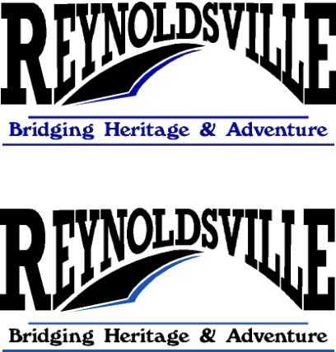

Reynoldsville Community Association



P.O. Box 53

Reynoldsville, PA 15851

[www.goreynoldsville.com](http://www.goreynoldsville.com)

_____________________________________________________________________________________________

March 1, 2019

Hello Neighbor,

Each year we send you a letter from our Blueprint Communities Initiative. It states that our goal was to raise $100,000 from local pledges as an investment in the future of our community. Currently we have raised $54,000, just over half of our goal. If you are keeping track, that’s an increase of $8,000, from a year ago.

Through a variety of fundraisers the Reynoldsville Community Association (RCA) raises money to sponsor two $500 scholarships each year. RCA organizes and promotes the annual Red, White & Blueberry Festival each July, as well as a Holiday Open House and Small Business Saturday in November. These encourage tourism and help local businesses. RCA has sponsored and organized a community Halloween dance for each of the past 5 years. RCA has obtained grants and raised matching funds to erect the electronic message board. A pocket park was completed at the base of the message board, also grant and match funded.

           RCA currently has full occupancy of the once vacant building located across from the borough building. This site now houses 4 apartments and 2 businesses, with renovations being completed for a third, new business, slated to open before summer. Last summer RCA received its own 501(c)(3) non-profit designation, allowing us to assist the Reynoldsville War Memorial Committee as they begin work on the planned veterans’ memorial park in the downtown.

Reynoldsville was designated a Blueprint Community in 2014. RCA is the organization through which we hope to accomplish the broader goals set forth in the five year action strategy. We work closely with Pennsylvania Downtown Center, Penn State Extension, DEP and any other grant funding organizations that allow us to further the money we raise through grant matches.

Future projects include new restrooms for the park/athletic field, a Riverwalk that could expand rails to trails, canoe launch and amphitheater. Setting guidelines and assisting businesses in applying for match funds, to restore facades and install period lighting as well as ADA accessibility throughout the downtown area, are also in our strategic plan.

RCA is a strictly volunteer organization. No compensation is offered to officers or volunteers. Members work for the improvement of our community. Please join us. Meetings are held on the second Thursday of each month, at the Ryan Law Offices 449 Main Street. Dates are posted on the electronic sign.

Thank you for your support of the efforts to revitalize our community. Please see below for information on the electronic sign and memberships.

***Community use of the electronic sign****:*

*\*Free to non-profit organizations.*

*\*All business memberships will include 14 days per year of no cost advertising on the electronic sign board.*

*\*Anyone can place information on the electronic sign board for $25 per week or $75 per month.*

***To get your message out…***

*Go to*[*www.goreynoldsville.com*](http://www.goreynoldsville.com) *and click on the Sign Requests button.*

Please consider a donation to our Capital Campaign which will include your membership in RCA. Your donation, in any amount, is appreciated.

Bronze-$51-250

Silver $251-500

Gold $501-1000

Platinum $1001-5000

Diamond over $5000

Annual memberships:  $20 Associate $100 Business

Note: Capital Campaign Donations **include** RCA membership

Name____________________________________________

Business_________________________________________

Address__________________________________________

Email____________________________________________

Membership [ ] $20 Associate [ ] $100 Business

Capital campaign donation __________________________

Make checks payable to Reynoldsville Community Association 501(C)(3)

Mail to Reynoldsville Community Association PO Box 53 Reynoldsville, PA 15851